day 1:

Assignment 1: explain network terminology.

**Network Terminology**

**1. Network**

A network is a group of two or more computers (or other electronic devices) connected together to share resources, like files and printers, or to communicate with each other.

**2. Internet**

The internet is a global network of networks. It's a massive system connecting millions of private, public, academic, business, and government networks.

**3. IP Address**

An IP address is a unique string of numbers separated by periods (IPv4) or colons (IPv6) that identifies each computer using the Internet Protocol to communicate over a network. Think of it like a home address for your computer.

* **IPv4 Example:** 192.168.1.1
* **IPv6 Example:** 2001:0db8:85a3:0000:0000:8a2e: 0370:7334

**4. Router**

A router is a device that forwards data packets between computer networks. It directs traffic on the internet, ensuring that data sent from one network reaches the correct destination.

**5. Modem**

A modem is a device that modulates and demodulates signals for communication over telephone lines, cable systems, or satellite links. It connects your home network to your Internet Service Provider (ISP).

**6. LAN (Local Area Network)**

A LAN is a network that connects computers within a limited area, such as a home, school, or office building. It’s typically used for sharing resources like files and printers.

**7. WAN (Wide Area Network)**

A WAN is a network that covers a broad area (e.g., any network whose communications links cross metropolitan, regional, or national boundaries). The internet is the largest WAN.

**8. Wi-Fi**

Wi-Fi is a technology that allows devices like computers, smartphones, and tablets to connect to the internet or communicate wirelessly within a particular area. It uses radio waves to transmit data.

**9. Ethernet**

Ethernet is a common method of networking computers in a LAN using wired connections. It typically uses cables like CAT5 or CAT6 to connect devices.

**10. Firewall**

A firewall is a security system that monitors and controls incoming and outgoing network traffic based on predetermined security rules. It acts as a barrier between a trusted network and an untrusted network.

**11. Bandwidth**

Bandwidth is the maximum rate of data transfer across a given path. It’s usually measured in bits per second (bps). Higher bandwidth means more data can be transmitted in a given amount of time.

**12. Latency**

Latency is the time it takes for a data packet to travel from its source to its destination. It’s often measured in milliseconds (MS). Lower latency means less delay.

**13. DNS (Domain Name System)**

DNS is like the phonebook of the internet. It translates human-friendly domain names (like [www.example.com](http://www.example.com)) into IP addresses that computers use to identify each other on the network.

**14. HTTP/HTTPS**

* **HTTP (Hypertext Transfer Protocol):** The foundation of any data exchange on the web and it’s a protocol used for transmitting hypertext requests and information between servers and browsers.
* **HTTPS (HTTP Secure):** It’s the secure version of HTTP, where communications are encrypted using SSL/TLS.

**15. VPN (Virtual Private Network)**

A VPN extends a private network across a public network and enables users to send and receive data as if their devices were directly connected to the private network. It provides security and privacy.

**16. Server**

A server is a computer or software program that provides services to other computers (clients) over a network. Examples include web servers, email servers, and file servers.

**17. Client**

A client is a computer or software program that requests services from a server. For example, your web browser is a client that requests web pages from web servers.

**18. Packet**

A packet is a small segment of data that is sent over a network. Packets contain both the data being transmitted and information about the data (like its destination).

**19. Switch**

A switch is a device that connects devices in a network and uses packet switching to forward data to the destination device. It operates at the data link layer (Layer 2) of the OSI model.

**20. Gateway**

A gateway is a network point that acts as an entrance to another network. It often involves translating between different protocols and making sure data gets routed to the correct destination.

Assignment 2: Draw your Home Network Topology and explain how you are accessing the RPS Lab environment.

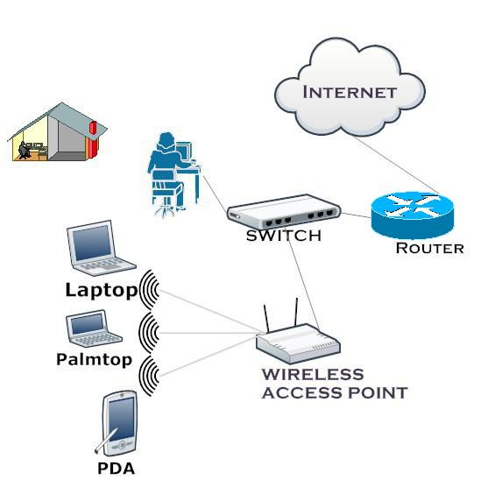

1. **Internet**: The starting point is the internet, which provides access to the global network of networks.
2. **Modem**: The modem connects to your Internet Service Provider (ISP) and converts the internet signal into a form that your home network can use.
3. **Router**: The router connects to the modem and directs traffic between the modem and the various devices in your home. It creates your home network, both wired and wireless.
4. **Devices**: Various devices in your home connect to the router. This includes:
   * **Smartphone**: Connects wirelessly to the router.
   * **Laptop**: Connects wirelessly to the router.
   * **Desktop Computer**: Usually connects to the router via an Ethernet cable for a stable connection.
   * **Smart TV**: Can connect wirelessly or via an Ethernet cable.
   * **Printer**: Can connect wirelessly or via an Ethernet cable.
   * **RPS Lab Computer**: A computer dedicated to accessing the RPS Lab environment, usually connected via Ethernet for a stable and fast connection.

### Accessing the RPS Lab Environment

To access the RPS Lab environment from your home network, you would typically follow these steps:

1. **Connect to the Internet**: Ensure your device (laptop, desktop, etc.) is connected to the home network via the router.
2. **VPN (Virtual Private Network)**: Many labs require a secure connection. You might need to use a VPN to securely connect to the RPS Lab network. The VPN will create a secure tunnel from your device to the lab's network.
3. **Remote Desktop Software**: Use software like Remote Desktop Protocol (RDP), VNC, or other remote access tools to connect to the specific computer or server in the RPS Lab. This software allows you to control the lab computer as if you were sitting right in front of it.
4. **Login Credentials**: Enter your lab credentials (username and password) to access the resources within the RPS Lab environment.